MODULE 5

Create a Bash script 'file_analyzer.sh', to demonstrate the following concepts:
- Recursive functions- Write a recursive function to search for files in a directory and its subdirectories containing a specific keyword.
2. Redirection and error handling- Log errors (e.g., invalid arguments, missing files) to 'errors.log' and display them in the terminal.
3. Here document and here string- Use a here document to display a help menu when the '--help' option is passed.- Search for a keyword in a specified file using a here string
4. Special parameters- Use parameters like '$0', '$#', '$?' and '$@' to provide meaningful feedback.
5. Regular expressions- Validate inputs with regular expressions (Check if the file exists and the keyword is not empty and valid)
6. Command-line arguments using getopts- Use 'getopts' to handle: '-d ': Directory to search. '-k ': Keyword to search. '-f ': File to search directly. '--help': Display the help menu.
Example usage: # Recursively search a directory for a keyword ./file_analyzer.sh -d logs -k error # Search for a keyword in a file ./file_analyzer.sh -f script.sh -k TODO # Display the help menu ./file_analyzer.sh –help

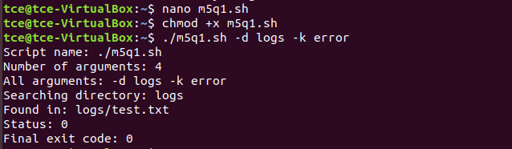
Error handling working:
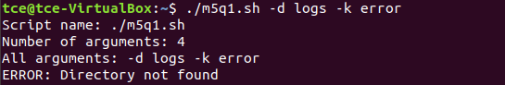
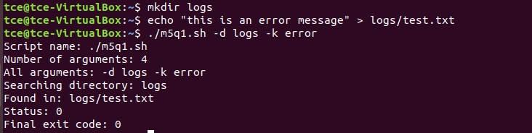

Scripts:
